Project Report
Import Data Using Transform Maps (Spreadsheet)
Platform | ServiceNow
Team ID | 6ab6292ddcdae33acb3906da
Date | 01 October 2026

Contents
1. Introduction
2. Ideation Phase
3. Requirement Analysis
4. Project Design
5. Project Planning & Scheduling
6. Functional and Performance Testing
7. Results
8. Advantages & Disadvantages
9. Conclusion
10. Future Scope
11. Appendix

1. Introduction

1.1 Project Overview
This project shows how to bring employee training data from a spreadsheet into ServiceNow and keep it secure. An Excel (.xlsx) file is loaded into an import set table, a transform map moves the rows into a custom table called Employee Training Records, and each record is linked to an employee in the sys_user table. The employee's department is pulled into the record by dot-walking. Finally, a custom Hr Manager role and Access Control Lists (ACLs) decide who can read and write the records, and the result is tested by impersonating different users.

1.2 Purpose
The purpose of the project is to give a simple, repeatable way to load bulk data into ServiceNow without typing each record, to link every record to an employee and show employee details such as department for easier reporting, and to protect the data with role-based access control.

2. Ideation Phase

2.1 Problem Statement
Training records are kept in spreadsheets and typed into the system one by one, which is slow and error-prone. Each record also has to be linked to an employee, and details such as the employee's department must be available in the record for easier reporting. At the same time, only the right people should be able to see or change these records.

2.2 Empathy Map Canvas
Persona: an HR administrator who maintains employee training records in ServiceNow.
Says | Thinks
"I have 20 rows in a spreadsheet, I don't want to type them again."  "Which employee does this training belong to?" | "Will the import create duplicates or wrong values?"  "Can anyone else see these records?"

Does | Feels
Prepares the spreadsheet, uploads it, maps columns to fields, runs the transform and checks the records. | Worried about mistakes in the data and about leaking personal information; relieved when the import shows Success.

Pains | Gains
Manual data entry; mismatched column names and choice values; no department shown in the record; unclear who has access. | Fast bulk import; employee and department shown automatically; only HR managers can view and edit the data.

2.3 Brainstorming
Ideas the team considered:
- Enter each training record manually in the form.
- Import the spreadsheet directly into the target table.
- Load the spreadsheet into an import set (staging) table and use a transform map to move it into the target table.
- Copy the department into each record with a script, or show it through dot-walking.
- Hide the data with a client script, or protect it with roles and ACLs.
Selected approach: Import Set with a Transform Map, because staged rows can be checked before they reach the real table; dot-walking, because the department stays in one place (sys_user); and roles with ACLs, because they are enforced by the platform on every request.

3. Requirement Analysis

3.1 Customer Journey Map
The journey of the administrator who imports and secures the data:
Phase | Steps | Goal | Positive | Negative | Opportunity
Prepare | Clean the spreadsheet; choose the target table and key | Avoid bad data and duplicates | A tidy sheet makes later steps smooth | Unclear key column; merged or blank headers | Keep a template sheet with exact headers
Load | Create the data source; upload the file with Load Data | Get the file in without manual entry | Headers become fields automatically; nothing touches the target yet | Wrong sheet or header row loads wrong data | Test with a few rows first
Map | Create the transform map; add field maps | Connect columns to the right fields | Auto Map handles matching names | References and choices must match exactly | Normalize values before loading
Transform | Run the transform | Run once and get it right | Many rows moved in one click | Vague errors; reruns can repeat rows | Use coalesce to update, not duplicate
Verify | Check records; dot-walk department; set roles and ACLs; test by impersonation | Trust the result and protect the data | Row status is clear; ACLs enforce access | Easy to forget the ACL on the table | Test every role before release

3.2 Solution Requirement
Functional requirements
FR No. | Requirement | Sub-requirement
FR-1 | Table setup | Create Employee Training Records with Training Name, Completion Date, Status (choice) and Employee (reference to sys_user)
FR-2 | Data import | Load an .xlsx file with Load Data into an import set table
FR-3 | Transformation | Create a transform map and field maps, then run the transform
FR-4 | Employee details | Show Employee.Department on the form and list by dot-walking
FR-5 | Roles and users | Create a user and the Hr Manager role; add the role to the application menu and module
FR-6 | Access control | Create read and write ACLs that require the Hr Manager role
FR-7 | Testing | Verify access by impersonating an HR manager and another user

Non-functional requirements
NFR No. | Requirement | Description
NFR-1 | Usability | Uses standard ServiceNow forms and lists; no coding is needed
NFR-2 | Security | Only users with the Hr Manager role can read or write the table
NFR-3 | Reliability | Staging table lets rows be checked before they reach the target table
NFR-4 | Performance | Bulk rows load in one operation; department is read through dot-walking, not copied
NFR-5 | Availability | Runs on the ServiceNow-hosted cloud instance
NFR-6 | Scalability | The same transform map can be reused for later imports

3.3 Data Flow Diagram
The diagrams show how data moves from the spreadsheet into ServiceNow and how access is controlled.
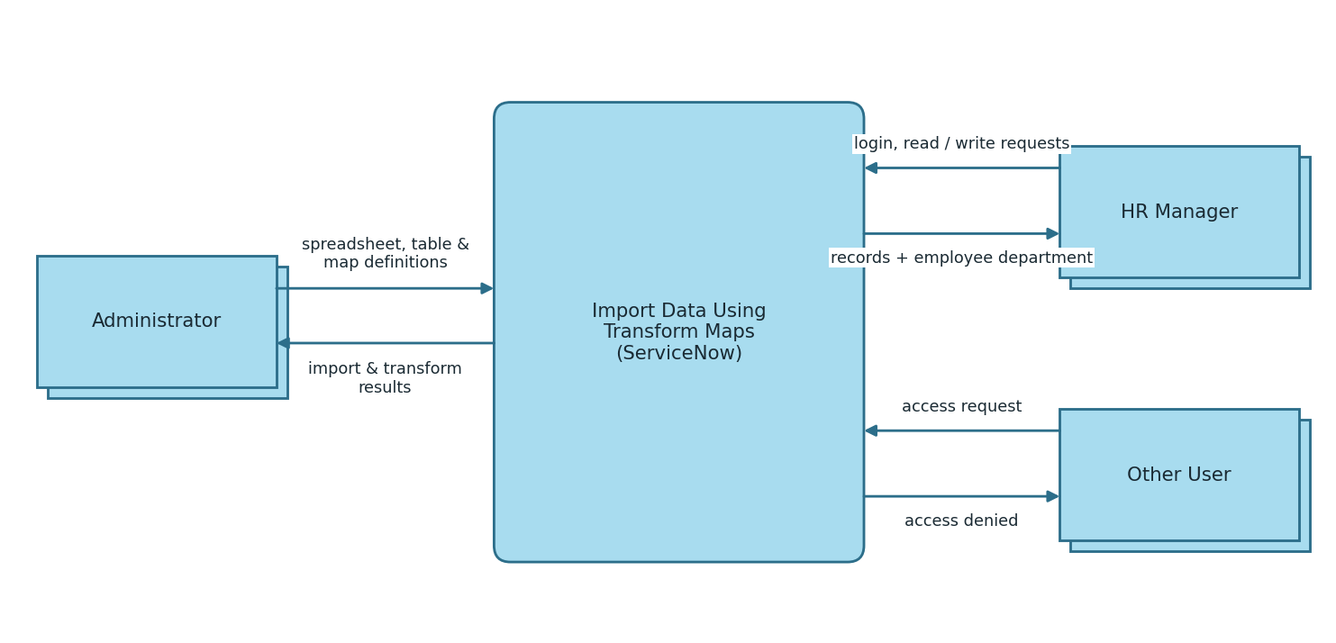
Figure 3.1: DFD Level 0
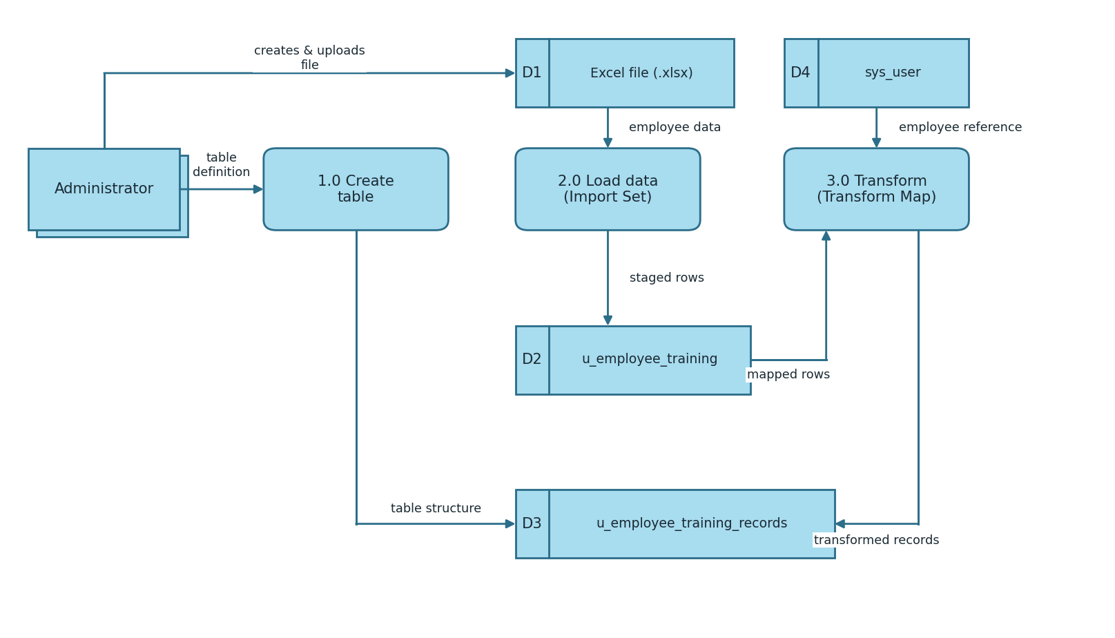
Figure 3.2: DFD Level 1 (importing data with a transform map)
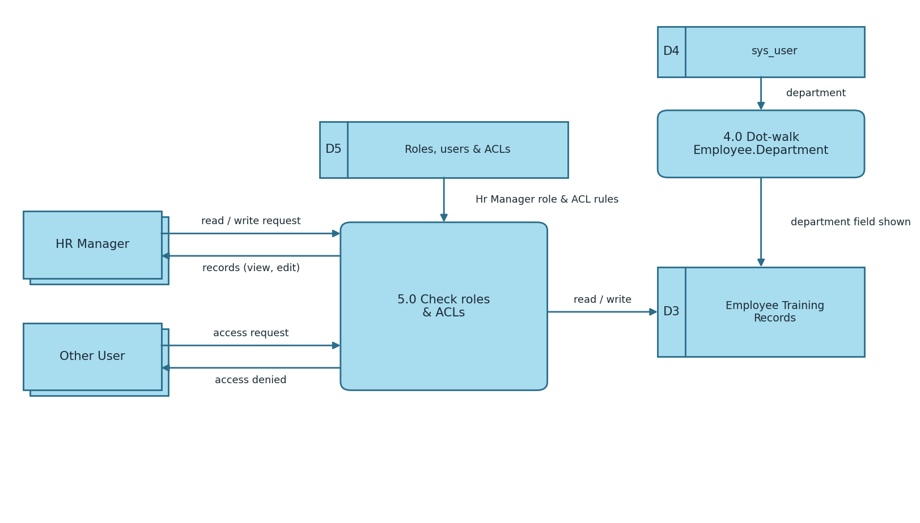
Figure 3.3: DFD Level 1 (dot-walking and access control)

3.4 Technology Stack
S.No | Component | Technology
1 | User Interface | ServiceNow Next Experience (Platform UI) in a web browser
2 | Application Logic-1 (Data import) | Import Sets (Load Data)
3 | Application Logic-2 (Transform) | Transform Map and Field Maps
4 | Application Logic-3 (Dot-walking) | Form Layout (dot-walking)
5 | Application Logic-4 (Access control) | Roles, Users and Access Control (ACL)
6 | Database | Tables u_employee_training, u_employee_training_records and sys_user
7 | Cloud Database | ServiceNow cloud instance database
8 | File Storage | Google Sheets / Excel (.xlsx) uploaded through Load Data
9 | External API / Machine Learning | Not used
10 | Infrastructure | ServiceNow cloud instance (application scope: Global)

4. Project Design

4.1 Problem Solution Fit
Problem | Why it hurts | How the solution fits
Typing records one by one | Slow and error-prone | Bulk import from a spreadsheet with Load Data and a transform map
Records not tied to employees | Reporting is difficult | Employee reference field to sys_user
Department missing in the record | Extra lookup needed | Dot-walking shows Employee.Department
Anyone could open the data | Privacy risk | Hr Manager role with read and write ACLs

4.2 Proposed Solution
Create a custom table for training records and load the spreadsheet into an import set (staging) table. A transform map with field maps moves the rows into the custom table and links each row to an employee. The employee's department is added to the form and list by dot-walking. A new Hr Manager role is added to the application menu, the module and the read and write ACLs, so only HR managers can see and edit the records. The result is tested by impersonating an HR manager (access granted) and another user (access denied).

4.3 Solution Architecture
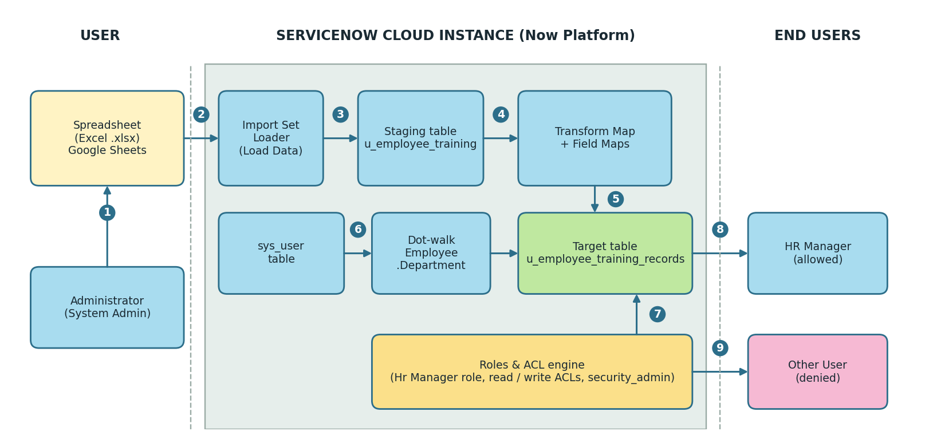
Figure 4.1: Solution architecture
The administrator uploads the spreadsheet to the ServiceNow instance. The Import Set Loader stages the rows in u_employee_training, the transform map inserts them into u_employee_training_records, and dot-walking reads the department from sys_user. The Roles and ACL engine checks every request: the HR manager is allowed and other users are denied.

5. Project Planning & Scheduling

5.1 Project Planning
Product backlog and sprint schedule
Sprint | Epic | User Story No. | User Story / Task | Story Points | Priority
Sprint-1 | Table creation | USN-1 | As an administrator, I can create the Employee Training Records table. | 2 | High
Sprint-1 |  | USN-2 | As an administrator, I can add the fields Training Name, Completion Date, Status and Employee. | 2 | High
Sprint-1 |  | USN-3 | As an administrator, I can add the choice values to the Status field. | 1 | Medium
Sprint-1 | Data import | USN-4 | As an administrator, I can prepare the .xlsx file. | 1 | High
Sprint-1 |  | USN-5 | As an administrator, I can upload the file using Load Data. | 2 | High
Sprint-1 | Transform map | USN-6 | As an administrator, I can create a transform map. | 2 | High
Sprint-1 |  | USN-7 | As an administrator, I can add field maps. | 3 | High
Sprint-1 |  | USN-8 | As an administrator, I can run the transform. | 2 | High
Sprint-2 | Dot-walking | USN-9 | As an administrator, I can dot-walk Employee.Department onto the form layout. | 3 | Medium
Sprint-2 | Roles & users | USN-10 | As an administrator, I can create a new user (backup user). | 1 | High
Sprint-2 |  | USN-11 | As an administrator, I can create the Hr Manager role. | 1 | High
Sprint-2 |  | USN-12 | As an administrator, I can assign the Hr Manager role to the user. | 2 | High
Sprint-2 |  | USN-13 | As an administrator, I can add the role to the application menu and module. | 3 | Medium
Sprint-3 | ACL | USN-14 | As an administrator, I can elevate my role to security_admin. | 1 | High
Sprint-3 |  | USN-15 | As an administrator, I can create a read ACL for the Hr Manager role. | 3 | High
Sprint-3 |  | USN-16 | As an administrator, I can create a write ACL for the Hr Manager role. | 2 | High
Sprint-3 | Testing | USN-17 | As an HR manager, I can view and edit the records. | 3 | High
Sprint-3 |  | USN-18 | As another user, I cannot see the table. | 2 | High

Project tracker
Sprint | Total Story Points | Duration | Sprint Start Date | Sprint End Date (Planned)
Sprint-1 | 15 | 6 Days | 05 Oct 2026 | 10 Oct 2026
Sprint-2 | 10 | 6 Days | 12 Oct 2026 | 17 Oct 2026
Sprint-3 | 11 | 6 Days | 19 Oct 2026 | 24 Oct 2026
Total | 36 | 18 Days
Velocity
Velocity = total story points / number of sprints = 36 / 3 = 12 story points per sprint. Average velocity per day = 12 / 6 = 2 story points per day.
Burndown chart
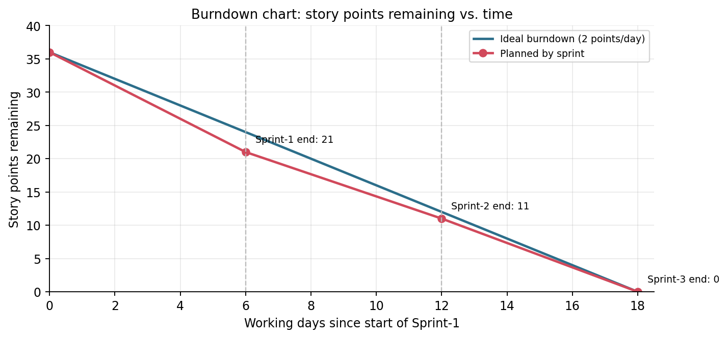
Figure 5.1: Burndown chart (ideal vs. planned by sprint)

6. Functional and Performance Testing

6.1 Performance Testing
User Acceptance Testing was carried out on each part of the project. The defect analysis shows resolved or closed bugs by severity and how they were resolved.
Resolution | Severity 1 | Severity 2 | Severity 3 | Severity 4 | Subtotal
By Design | 0 | 0 | 0 | 1 | 1
Duplicate | 0 | 0 | 0 | 0 | 0
External | 0 | 0 | 0 | 0 | 0
Fixed | 0 | 2 | 0 | 0 | 2
Not Reproduced | 0 | 0 | 0 | 0 | 0
Skipped | 0 | 0 | 0 | 0 | 0
Won't Fix | 0 | 0 | 0 | 0 | 0
Totals | 0 | 2 | 0 | 1 | 3
The test case analysis shows the number of test cases that passed, failed and were not tested.
Section | Total Cases | Not Tested | Fail | Pass
Table Creation | 4 | 0 | 0 | 4
Data Import | 3 | 0 | 0 | 3
Transform Map | 4 | 0 | 0 | 4
Dot-Walking | 2 | 0 | 0 | 2
Roles and Users | 4 | 0 | 0 | 4
Security (ACL) | 3 | 0 | 0 | 3
Result Testing (Impersonation) | 3 | 0 | 0 | 3
Totals | 23 | 0 | 0 | 23

7. Results

7.1 Output Screenshots
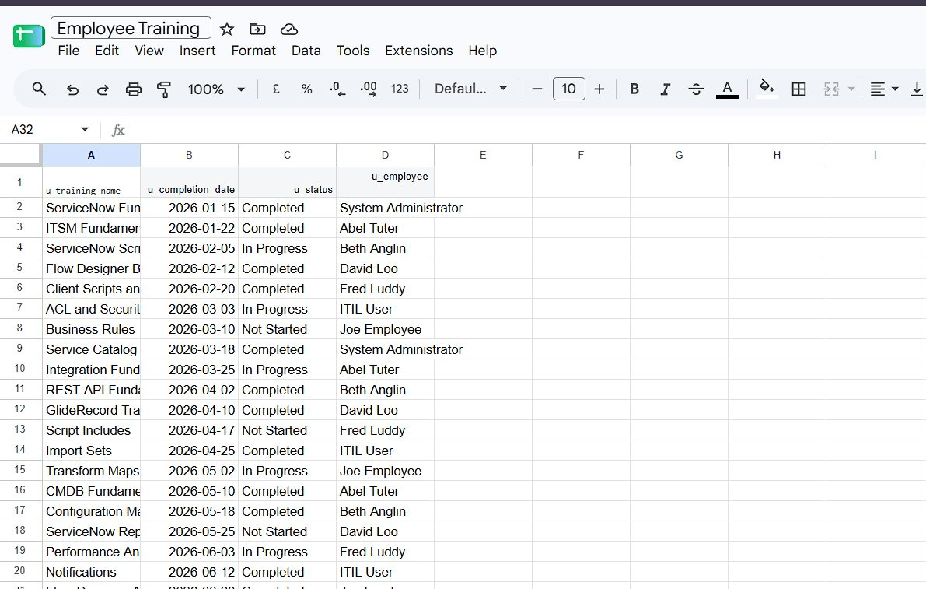
Figure 7.1: Employee Training spreadsheet (.xlsx) used as the data source
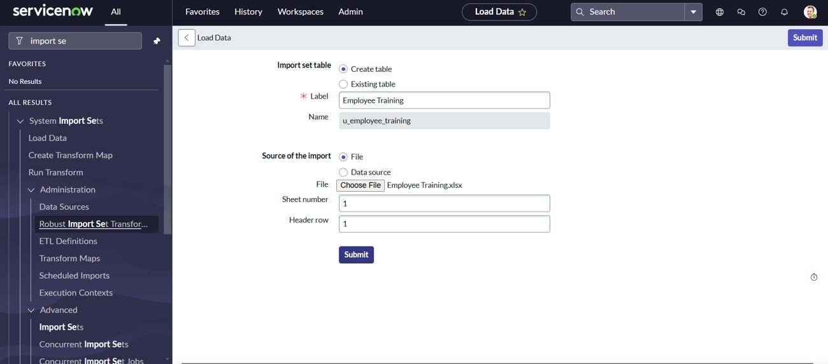
Figure 7.2: Load Data creates the import set table u_employee_training
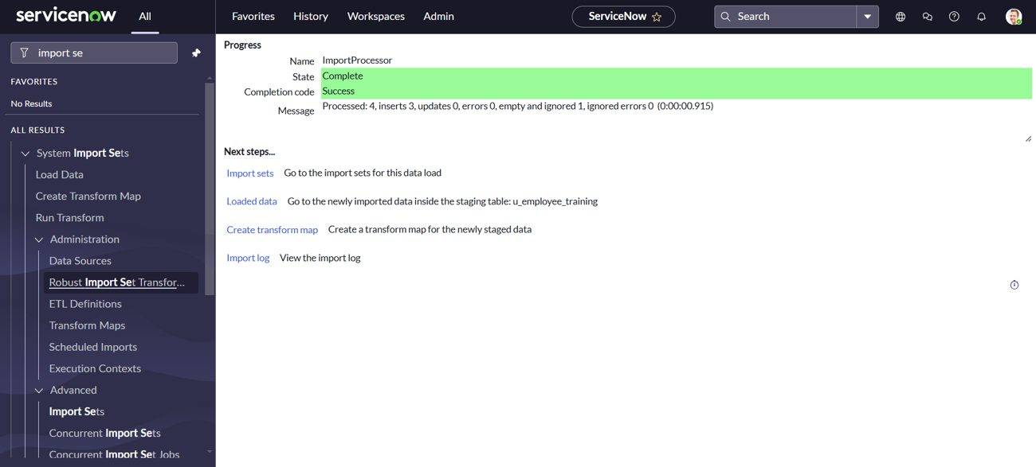
Figure 7.3: Import completed with State Complete and Success
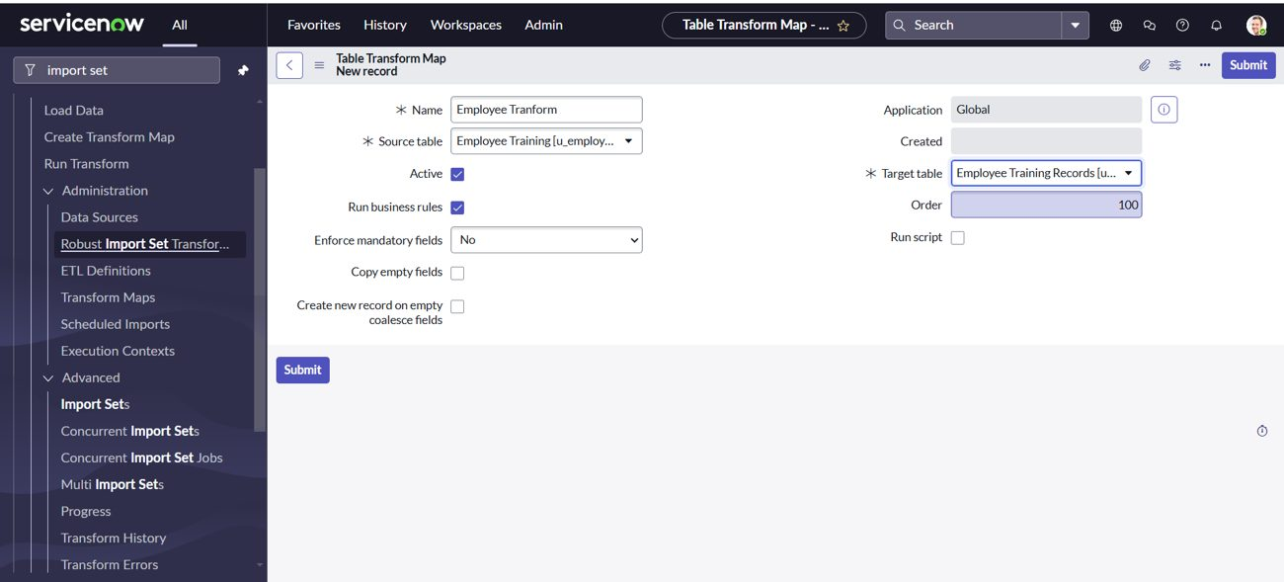
Figure 7.4: Transform map linking the import set table to the target table
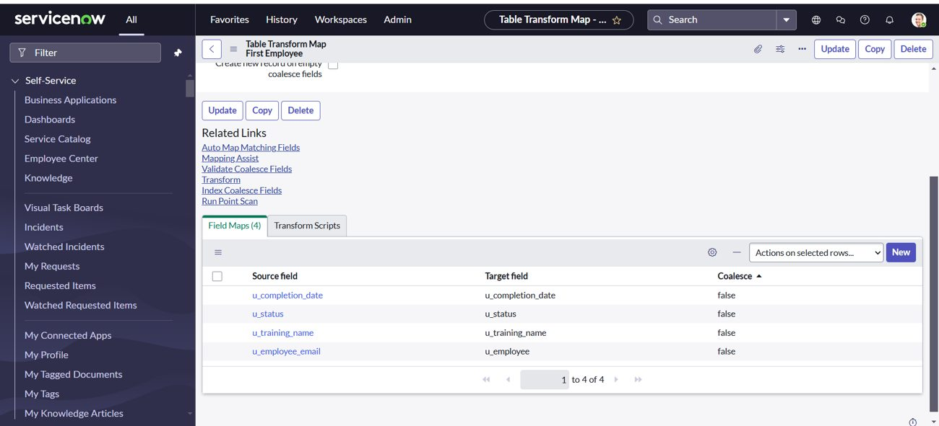
Figure 7.5: Field maps added to the transform map
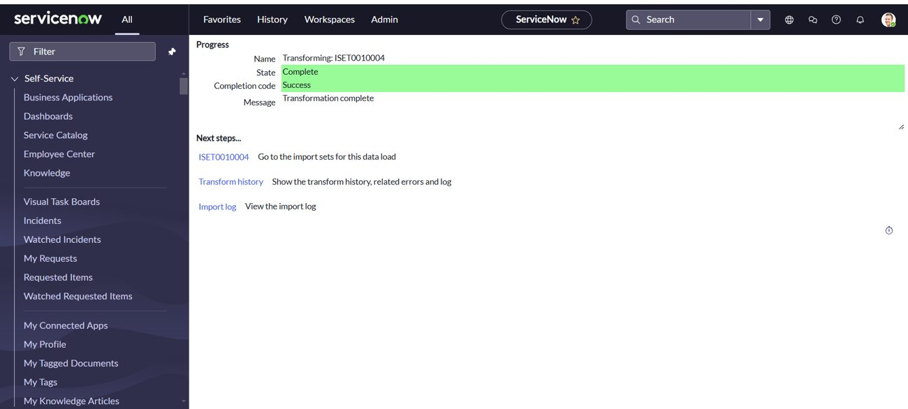
Figure 7.6: Transformation completed successfully
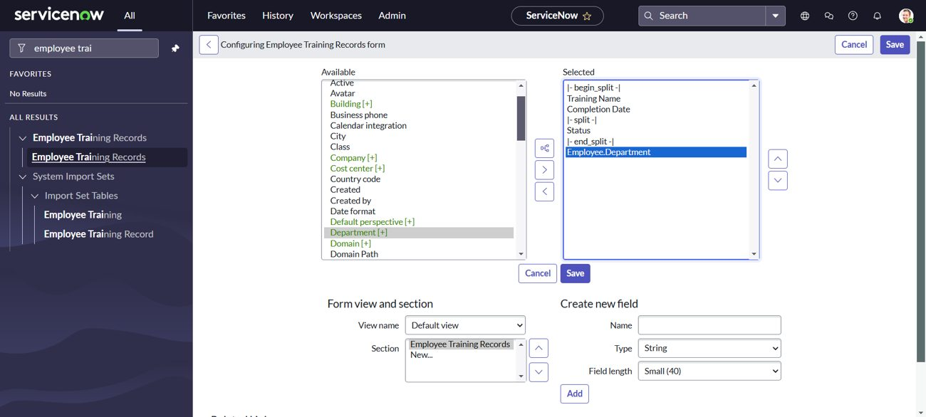
Figure 7.7: Dot-walking Employee.Department in the form layout
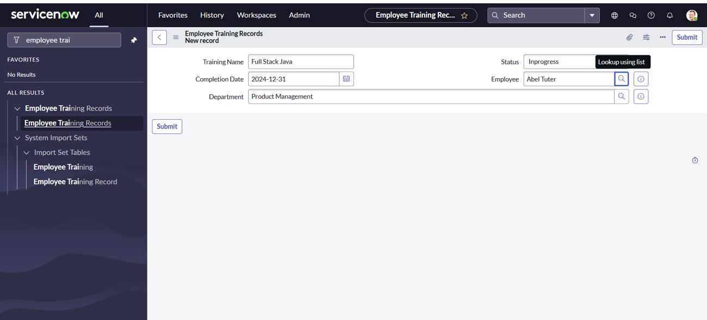
Figure 7.8: Employee Training Records form showing the Department field
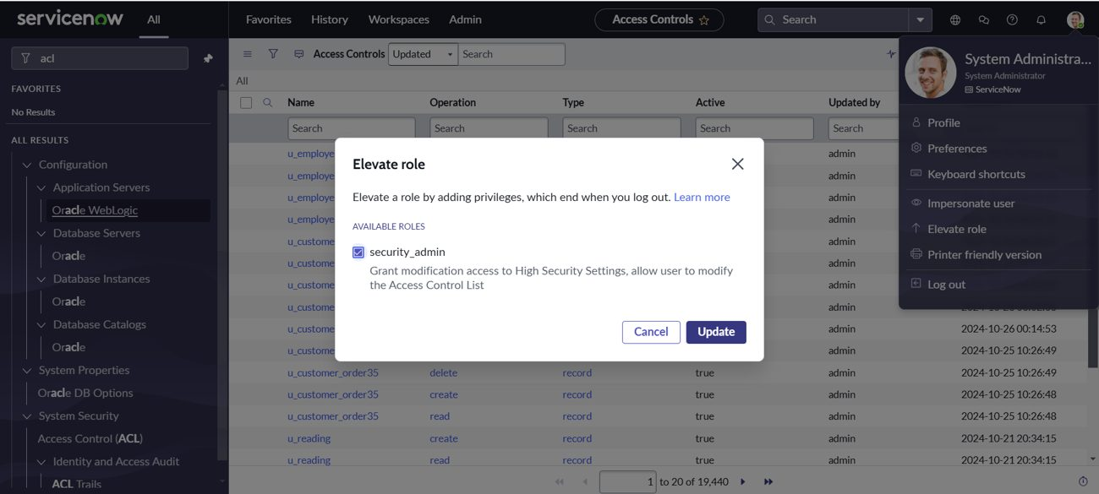
Figure 7.9: Elevating the role to security_admin
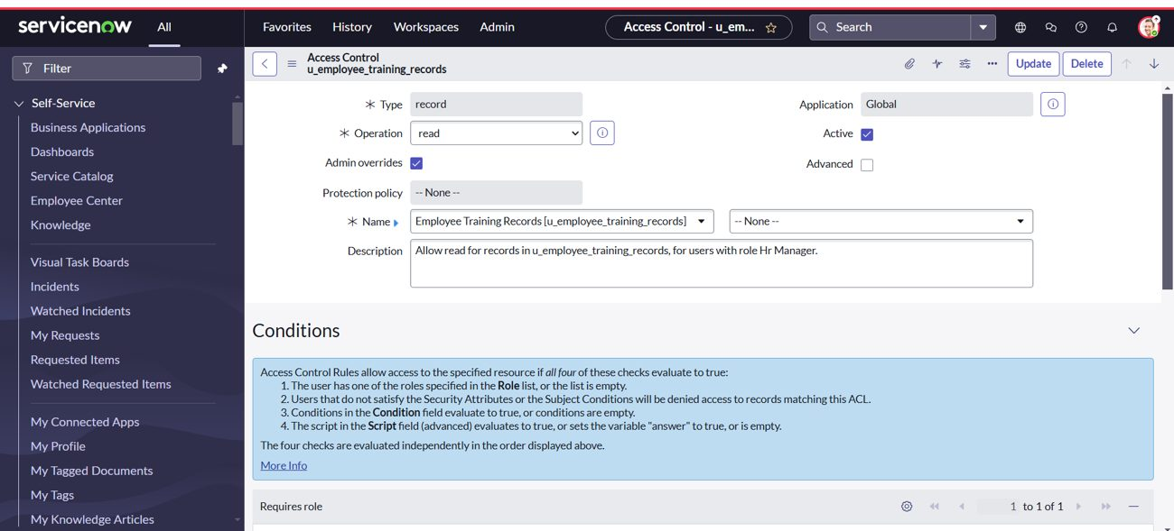
Figure 7.10: Read ACL on the Employee Training Records table
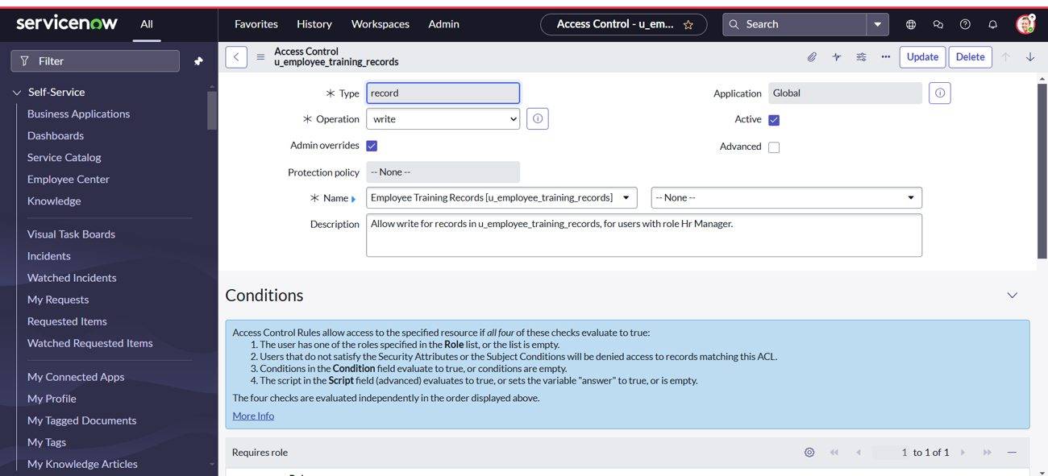
Figure 7.11: Write ACL on the Employee Training Records table
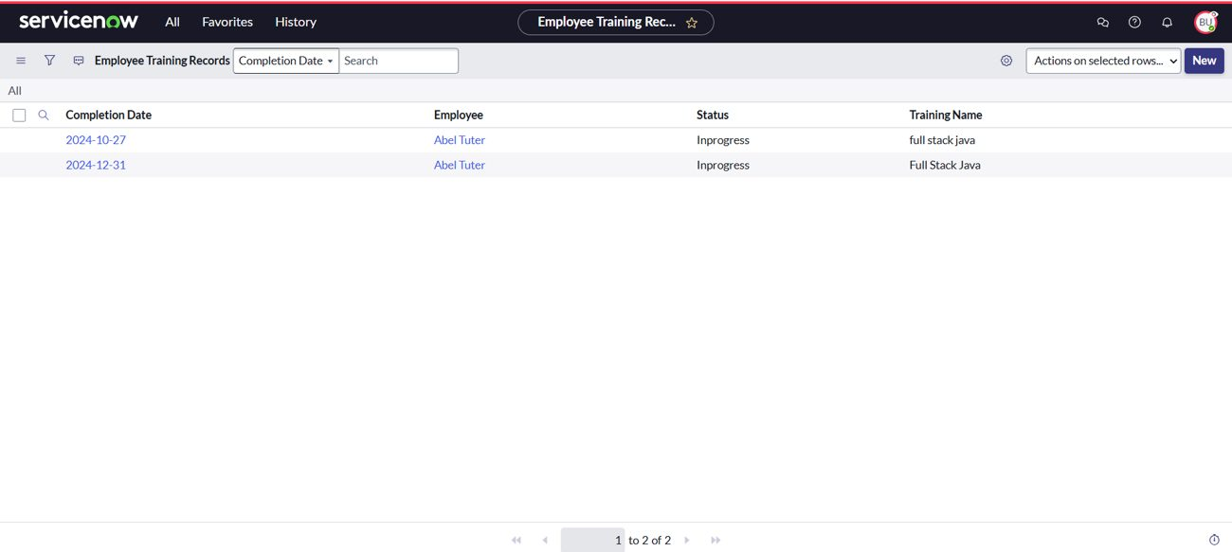
Figure 7.12: Employee Training Records visible to the user with the Hr Manager role
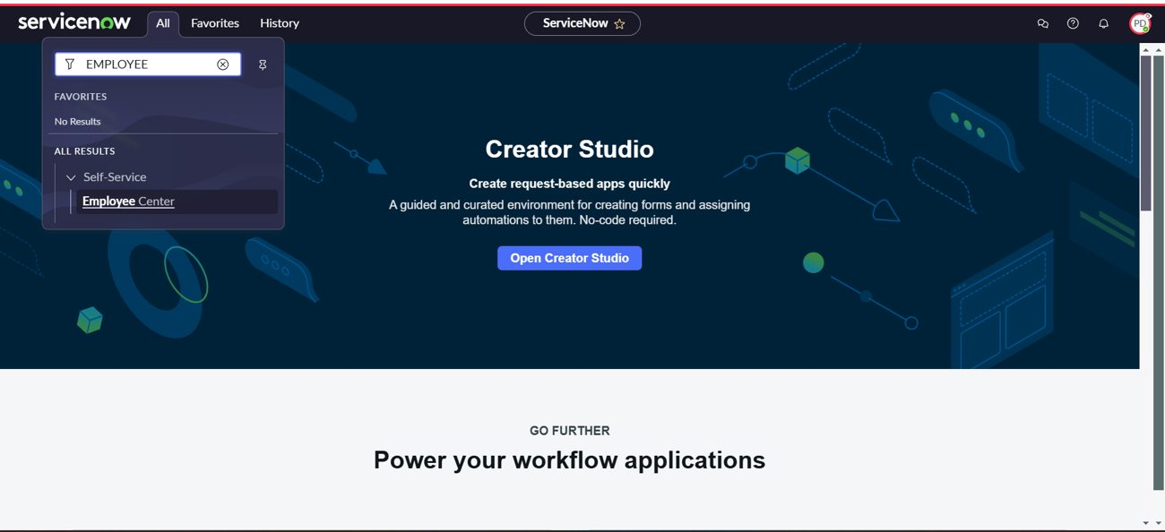
Figure 7.13: Other user cannot see the Employee Training Records table

8. Advantages & Disadvantages
Advantages
- Bulk data is loaded in minutes instead of being typed row by row.
- Staging table lets rows be checked before they reach the real table.
- Department comes from the employee record, so it stays correct without extra entry.
- Role-based ACLs protect the data on every request.
- No coding is needed; everything uses standard platform features.
Disadvantages
- Column names and choice values in the spreadsheet must match the table exactly, or rows fail or are skipped.
- Wrong or missing coalesce settings can create duplicate records.
- Reference fields need exact display values to be matched.
- ACLs need the security_admin role and careful testing.

9. Conclusion
This project demonstrated the essential process of importing data into ServiceNow using Import Sets and Transform Maps, using dot-walking to bring in related employee data, and applying ACLs to enforce data security. Together, these features gave accurate data integration, a clear link between each record and its employee, and protected sensitive information through role-based access control.

10. Future Scope
- Schedule recurring imports so new spreadsheets are loaded automatically.
- Set coalesce fields so repeated imports update existing records.
- Add transform scripts and choice actions to clean dates and status values.
- Build dashboards and reports on training status by department.
- Add notifications for pending or overdue training.
- Add field-level ACLs for more sensitive columns.

11. Appendix
Source Code (if any)
No custom source code was written. The project is configured with ServiceNow platform features (tables, import sets, transform maps, roles and ACLs).
Dataset Link
Dataset: Employee Training.xlsx (Training Name, Completion Date, Status, Employee). Link: [add your link here]
GitHub & Project Demo Link
GitHub: [add your link here] Project demo: [add your link here]

